



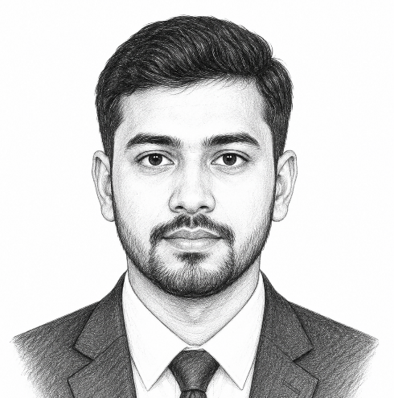




Contacts
CV Writer BD, Dhaka
resumeok2@gmail.com
cvwriterbd.com
+88 01816 630 600

Education

Dhaka International University (DIU)
  - Masters of Arts in Graphic Design,
  - CGPA: 3.70 (Out of 4.00)
  - Session: 2017-2018

Daffodil International University (DIU)
  - Bachelor of Arts in Graphic Design,
  - CGPA: 3.80 (Out of 4.00)
  - Session: 2014-2015

Dhaka Polytechnic Institute (DPI)
Bachelor of Arts in Graphic Design,
CGPA: 3.64 (Out of 4.00)
Session: 2010-2013

Working Experience

Senior Graphic Designer
  - Creative Design, Gazipur, Dhaka
  - Jan 2023 – Dec 2025

Graphic Designer
  - Print Media, Gazipur, Dhaka
  - Jan 2021 - Dec 2022

Junior Graphic Designer
  - Design Home, Gazipur, Dhaka
  - Jan 2019 – Dec 2020

Professional Profile
  - Motivated graphic designer with strong creative skills and attention to detail. Experienced in branding, digital design, and print materials. Adept at collaborating with teams and delivering visually compelling designs that meet client and business goals.

Sohel Ahammad
  - Senior Merchandiser

Hobbies
- Reading
- Writing
- Traveling

Languages
- English: Fluent
- Bengali: Fluent
- Hindi: Intermediate
- Arabic: Intermediate

Skills
- Visual Design & Layout
- Branding Design
- Photo Editing
- Digital Design
- Typography
- Composition Systems

