BIODATA
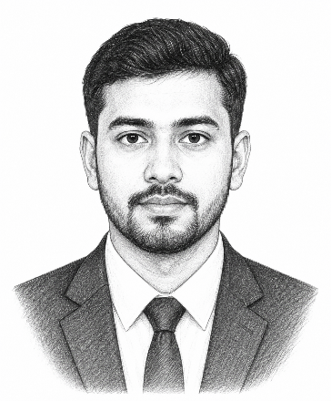
PERSONAL DETAILS
Name : Sohel Ahammad
Date of Birth : 16-08-2020
Place of Birth : Cumilla
Complexion : Medium
Height : 5 feet 7 inches
Weight : 67 Kg
Education : BSS Hons in Social Welfare
Blood Group : AB+
Marital Status : Single
Occupation : Banker, Dhaka Bank

FAMILY DETAILS
Father Name : Md. Manirul Islam
Father’s Occupation : Farmer
Mother Name : Hajera Begum
Mother’s Occupation : House Wife
Sister Name (Younger) : Maliha
Sister’s Occupation : Business
Brother in Law’s Occup. : Doctor
Uncle’s Occupation : Business

CONTACT DETAILS
Contact Number : Father: +8801721-000000
Mother: +8801912-000000
Present Address : Village: xxx , Thana: xxx, District: xxx
Permanent Address : House: xx, Road: xx, Dhaka, Bangladesh

