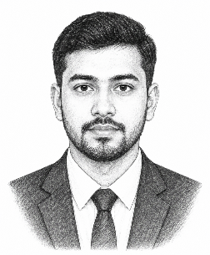
CURRICULUM VITAE

Contacts:

Mobile: +88 01816630600

Email: resumeok2@gmail.com
Dhaka, Bangladesh
PERSONAL DETAILS:

Name : Sohel Ahammad
Father’s Name : Monirul Islam
Mother’s Name : Tahera Begum
Permanent Address : Village: xxx, Post Office: xxx-3301
PS: xxx, District: xxx.
Date of Birth : 01-01-1998
Gender : Male
Blood Group : B+
Religion : Islam
Nationality : Bangladeshi
National ID No. : 123 123 0000
EDUCATIONAL QUALIFICATION:

Degree | Group | Board | Passing Year | Result
SSC | Science | Sylhet | 2014 | 4.86
HSC | Humanities | Sylhet | 2016 | 4.50
B.A. Honours | Political Science | National University | 2020 | 3.64
WORK EXPERIENCE:

SL | Company Name | Designation | Duration
01 | Akij Food & Beverage | Senior Executive | March 2023 to Till Now
02 | Beximco Computers Ltd. | Field Officer | Jan 2020 – Jan 2023
TECHNICAL SKILLS:

- Diploma in ICT, Bangladesh Computer Council.
- Expert in MS Word, MS Excel, MS Power Point, Adobe Photoshop & Illustrator.
- Typing Speed: English- 40 Word per minute, Bangla- 30 Word per minute.

Date: Signature

(Sohel Ahammad)

