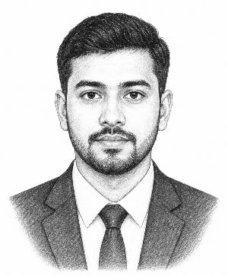
Curriculum Vitae
of
Sohel Ahammad

Mailing Address
1123 Dhanmondi, Dhaka, Bangladesh 1214
Mobile: 01816630600
Email: resumebd2@gmail.com
Career Objective

To secure a challenging entry-level position in any reputed organization where I can leverage my knowledge, skills, and work experience to contribute to the success of the organization while continuing to learn and grow as a professional.
Work Experience

General Manager (Project/Plant Head) Jul 2016 – Present
IFAD Autos Ltd, Dhaka, Bangladesh.
- Devise and execute strategic enhancements for production, quality, and workforce optimization across the facility.
- Lead efforts to ensure efficient utilization of plant personnel and equipment, fostering effective operational performance.
General Manager (Operations) Feb 2015 – Jun 2016
AKIJ Motors Ltd, Dhaka, Bangladesh
- Manage company operations for budget and financial success.
- Develop and implement policies aligned with company objectives. Collaborate with senior management on strategic plans and innovative processes.
Educational Details

Name of Examination | Year of Passing | Board/University | Obtained Class/Grade | Major Subject/Group
BSS (hons) | 2010 | National University | First Class | Social Work
HSC | 2004 | Dhaka Board | GPA 4.5 | Business Studies
SSC | 2002 | Dhaka Board | GPA 4.0 | Science
Language Proficiency

  - Bangla (Mother Tongue)
  - English (Fluent)
  - Arabic (Reading)

Computer Skills

- Good command in Microsoft Word, Excel and PowerPoint.
- Email correspondents &
- Internet browsing.
Extra-curricular Activities

President, University Debate Club
- Organized weekly public speaking workshops for 50+ members.
- Managed a $2,000 club budget for tournament travel.
- Led the team to win first place at the Regional Championship.
Personal Information:

Father’s Name : Md. Manirul Islam
Mother’s Name : Tahera Begum
Permanent Address : Vill: Dhaka, PO: Dhaka, PS: Dhaka
Dist: Dhaka
Date of Birth : 20 Jan 1986
Religion : Islam
Marital Status : Married
Blood Group : AB+
Nationality : Bangladeshi
National ID No. : 123 123 1234
References

Name  Address  Cell:  Email: | Name  Address  Cell:  Email:

I, the undersigned, certify that the information contained in this resume is accurate and true to the best of my knowledge.

Signature

(Sohel Ahammad)
Date : ......................

